 | 26.10.2 Editors - Properties Editor - Particle Properties Tab - Emitter - Emission Panel
Table of content
Emission Panel 1
Number 1
Seed 1
Frame Start 1
End 2
Lifetime 2
Lifetime Randomness 2
Source 2
Emit From 2
Vertices 2
Use Modifier Stack 2
Random Order 2
Faces & Volume 2
Use Modifier Stack 3
Distribution 3
Jittered 3
Random Order 3
Even Distribution 3
Particles/Face 3
Jittering Amount 3
Random 3
Random Order 3
Even Distribution 3
Grid 3
Invert Grid 3
Hexagonal Grid 3
Resolution 3
Random 3

Emission Panel
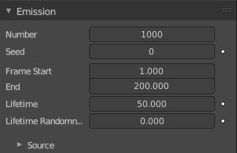
The buttons in the Emission panel control the way particles are emitted over time.

Number
The maximum amount of parent particles used in the simulation.

Seed
Blender uses this as starting point to produce random numbers during the simulation.

Frame Start
The start frame of particle emission. You may set negative values, which enables you to start the simulation before the actual rendering.

End
The end frame of particle emission.

Lifetime
The lifespan (in frames) of the particles.

Lifetime Randomness
A random variation of the lifetime of a given particle. The shortest possible lifetime is Lifetime × (1 - Random). Values above 1.0 are not allowed. For example with the default Lifetime value of 50 a Random setting of 0.5 will give you particles with a live span ranging from 50 frames to 50×(1.0-0.5)=25 frames, and with a Random setting of 0.75 you will get particles with live spans ranging from 50 frames to 50×(1.0-0.75)=12.5 frames.

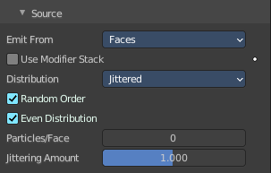
Source

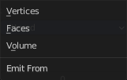
Emit From
Defines how and where the particles are emitted, giving precise control over their distribution. Defines also what content is displayed in the source sub panel.
Tip! You may use vertex groups to confine the emission, that is done in the Vertex Groups panel.

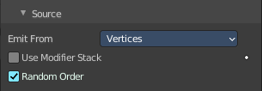
Vertices
Emits particles from the vertices of a mesh.

Use Modifier Stack
Take any Modifiers above the Particle Modifier in the modifier stack into account when emitting particles, else it uses the original mesh geometry.

Random Order
The emitter element indices are gone through in a random order instead of linearly (one after the other).

Faces & Volume
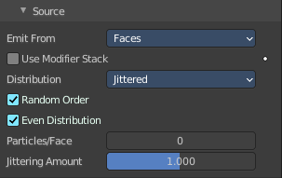
Faces emits particles from the surface of a mesh’s faces.
Volume emits particles from the volume of an enclosed mesh. Your mesh must be manifold to emit particles from the volume. Some modifiers like the Edge Split Modifier break up the surface, in which case volume emission will not work correctly!

Use Modifier Stack
Take any Modifiers above the Particle Modifier in the modifier stack into account when emitting particles, else it uses the original mesh geometry.

Distribution
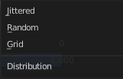
These settings control how the emissions of particles are distributed throughout the emission locations when emitting from either Faces or Volume.

Jittered

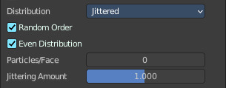
Random Order
The emitter element indices are gone through in a random order instead of linearly (one after the other).

Even Distribution
Particle distribution is made even based on surface area of the elements, i.e. small elements emit less particles than large elements, so that the particle density is even.

Particles/Face
Number of emissions per face (0 = automatic).

Jittering Amount
Amount of jitter applied to the sampling.

Random

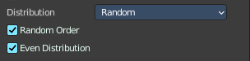
Random Order
The emitter element indices are gone through in a random order instead of linearly (one after the other).

Even Distribution
Particle distribution is made even based on surface area of the elements, i.e. small elements emit less particles than large elements, so that the particle density is even.

Grid

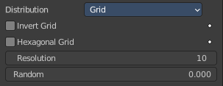
Invert Grid
Invert what is considered the object and what is not.

Hexagonal Grid
Uses a hexagonal-shaped grid instead of a rectangular one.

Resolution
Resolution of the grid.

Random
Add a random offset to grid locations.

